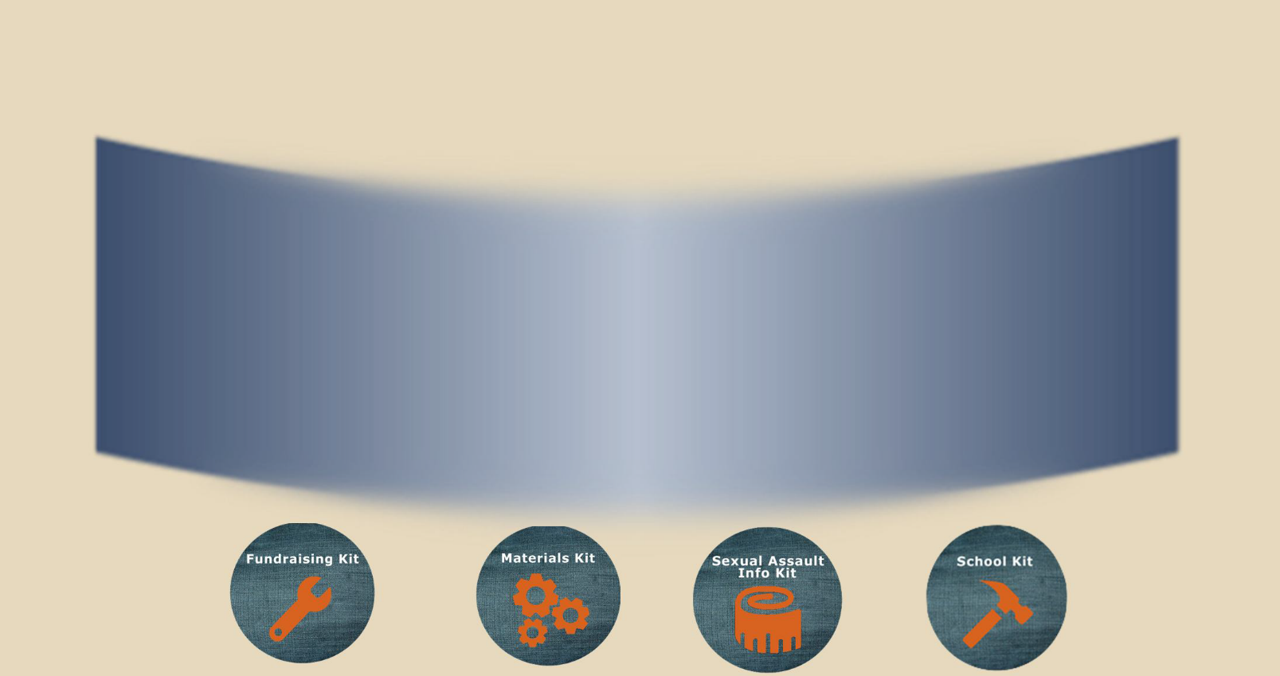
April 26,
2023
Wear Jeans
Support A Survivor

Believe Survivors. Speak Out. Make Change.

A day to honor survivo rs of sexual assault and bring awareness to the dange rs of victim blaming.
Denim Day is a day to wear jeans in support of sexual assault awareness. Wecelebrate Denim Day in honor of a woman who was forcibly raped by her driving instructor. The woman pressed charges, but the case was dismissed because the chief judge decided that, “... because the victim wore very, very tight jeans, she had to help him remove them, and by removing the jeans it was no longer rape, but consensual sex.”

Knowledge Empowers!
Visit us at:
facebook.com/DenimDayMilwaukee denimdaymilwaukee.wix.com/personsofinfluence
denimdaymke.org

Sexual Assault Treatment Center Pathfinders The Healing Center
414-219-5555 414-964-2565 414-671-4325
aurora.org/Services/Sexual-Assault/ SATC pathfindersmke.org TheHealingCenter.org

