Believe Survivors. Speak Out. Make Change.

A day to honor survivors of sexual assault and
bring awareness to the dangers of victim blaming.
Denim Day is a day to wear jeans in support of sexual assault awareness. We celebrate Denim Day in honor of a woman who was forcibly raped by her driving instructor. The woman pressed charges, but the case was dismissed because the chief judge decided that, “... because the victim wore very, very tight jeans, she had to help him

remove them, and by removing the jeans it was no longer rape, but consensual sex.”

Wear Jeans
Support A Survivor

April 27,

2022

denimdaymke.or g
facebook.com/
DenimDayMilwaukee

Believe Survivors. Speak Out. Make Change.

A day to honor survivors of sexual assault and
bring awareness to the dangers of victim blaming.
Denim Day is a day to wear jeans in support of sexual assault awareness. We celebrate Denim Day in honor of a woman who was forcibly raped by her driving instructor. The woman pressed charges, but the case was dismissed because the chief judge decided that, “... because the victim wore very, very tight jeans, she had to help him

Denim Day Milwaukee

remove them, and by removing the jeans it was no longer rape, but consensual sex.”

Wear Jeans
Support A Survivor

April 27,
2022

denimdaymk e.or g
facebook.com/
DenimDayMilwauk ee

denimdaymke.org
Knowledge Empowers!
Visit us at:
facebook.com/DenimDayMilwaukee
denimdaymilwaukee.wix.com/personsofinfluence
Join The Movement:

Sexual Assault Treatment Center
414-219-5555
Aurora.org/ Services/ Sexual-Assault/ SATC

Pathfinders
414-964-2565
Pathfindersmke.org The Healing Center 414-671-4325
TheHealingCenter.org

Sign up to Support Denim Day
Fundraising Workplace
Dollar Dress Down Social Media Flyers
Printable Stickers

denimdaymke.org
Join The Movement:

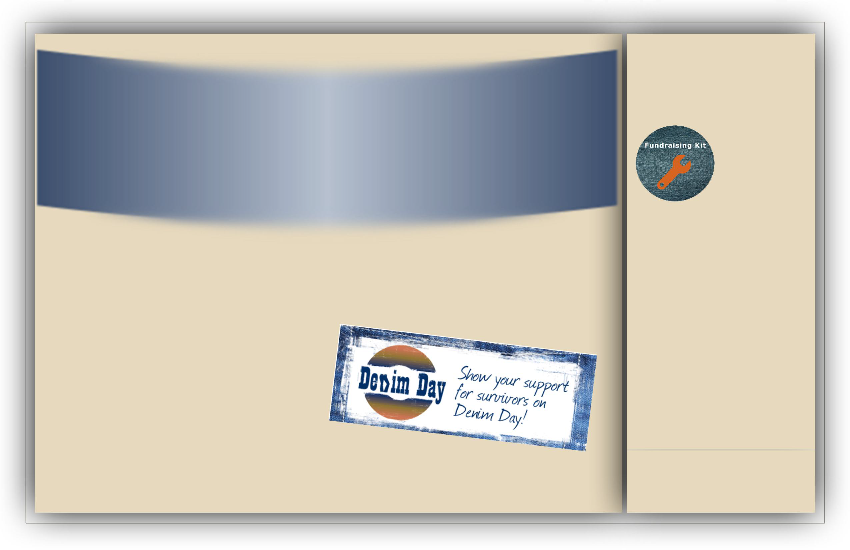
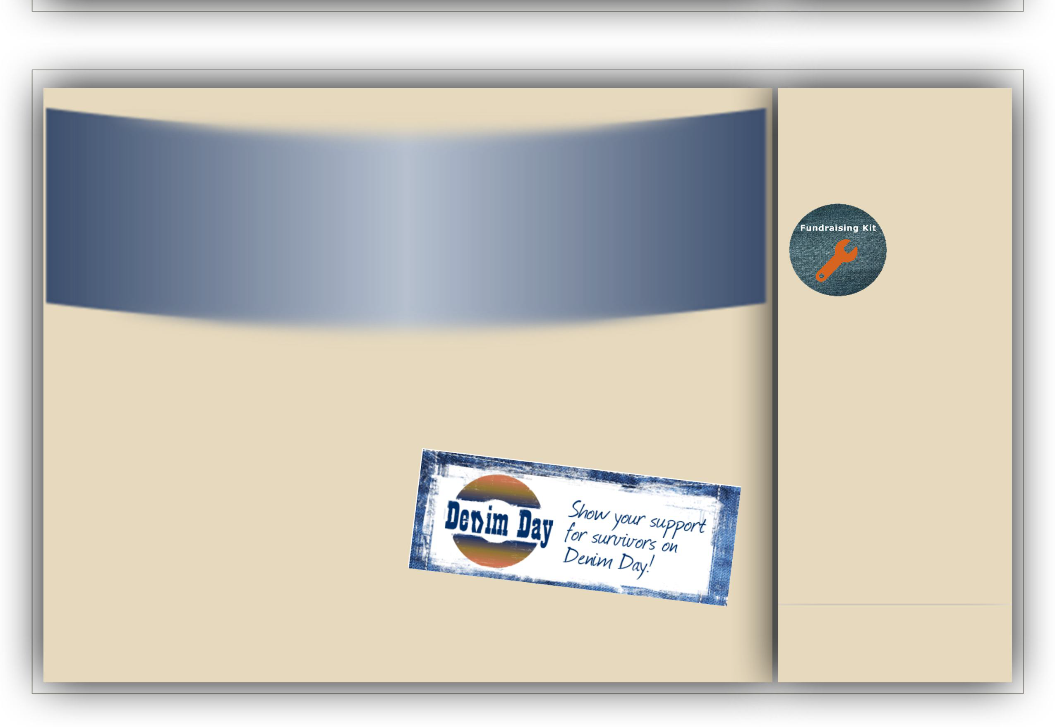
Sexual Assault Treatment Center
Knowledge Empowers!
Visit us at:
facebook.com/DenimDayMilwaukee
denimdaymilwaukee.wix.com/personsofinfluence
414-219-5555
Aurora.org/ Services/ Sexual-Assault/ SATC

Pathfinders
414-964-2565
Pathfindersmke.org The Healing Center 414-671-4325
TheHealingCenter.org

Sign up to Support Denim Day
Fundraising Workplace
Dollar Dress Down Social Media Flyers
Printable Stickers

